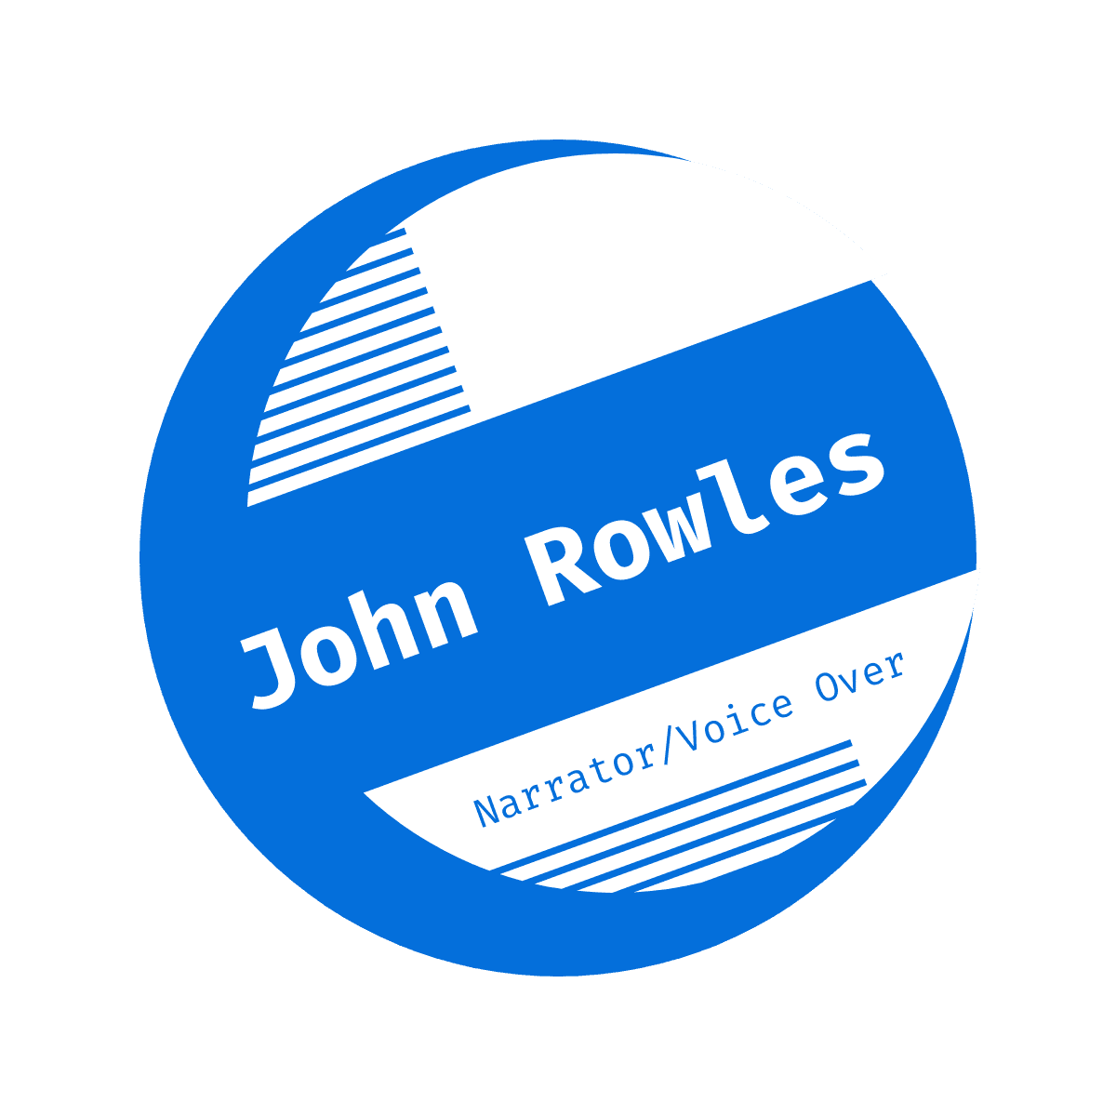
703.785.6402 cubiclecultures@gmail.com voiceoverandtech.com
My latest project, Transformative by Omar Katerji, is available on Audible and Amazon!

Voice: Bountiful, Burly, and Salving voice like a comfortable pair of well-worn jeans.
NONFICTION – BUSINESS
- Transformative by Omar Katerji / ACX

NON-FICTION - VIDEO
- McAlester Army Ammunition Plant, YouTube
- The Nexus of Climate Change, Migration, & Security Climate Change, Security in South Asia, Center for American Progress

FICTION - VIDEO
- Marine Encounter by John Patricio, YouTube
- My Bare Hands by John Patricio, YouTube
- A short history of sending wish lists to Santa Claus reminds us why we love the Internet, Mashable
- The Ultimate Event by Citra Productions, Vimeo
- Mancession by Citra Productions, Vimeo
- Herbocide by Tim Flaherty Media, Vimeo

PERFORMANCE
- 30+ years of live performance as a drummer and lead guitarist for rock/blues/rhythm & blues bands
- 5 years of on-air radio experience at WMDM/WPTX and WTKX TK101
- Music composition and performance for short and feature length independent films
- Pro-bono music composition and performance work for multiple Fairfax Public Access television shows
- Multiple awards from TIVA and 48Hour Film Project for narration and original music composition
- Narration and music have appeared in over a dozen film festivals
- E-Lit Author award for Manku – Haiku From A Man’s Point Of View

AUTHOR
- Manku and Manku Too, Amazon

EDUCATION
- MBA - Marymount University, Arlington, VA
- B.S. Business – University of Mobile, Mobile, AL
- ITIL: Foundations, Release Control and Validation, Operational Support and Analysis
- Six Sigma Lean Professional
- Six Sigma Green Belt
- Change Management Specialist
- Certified Kaizen Facilitator

MILITARY SERVICE
- United States Navy – 1990-1993 - NSGA Fort Meade, MD

TRAINING
- Sean Pratt – Audiobook Narration
- Racheal Naylor and Alan Shires – The Voice Over Network
- Raul Aldana – Dubbing Techniques
- Eric Stuart – Anime
- Kevin Rehr and Natalie Lyon – Voice Acting the Pixar Way

STUDIO & EQUIPMENT
- Mic: AKG C214
- Interface: MOTU 2
- Booth: Clear Sonic
- DAW: Studio One, Audacity
- Mac i/OS

